in this lesson, you'll get an introduction to machine learning (ML) with AWS and AWS AI devices: AWS DeepLens, AWS DeepComposer, and AWS DeepRacer. Learn the basics of computer vision with AWS DeepLens, race around a track and get familiar with reinforcement learning with AWS DeepRacer, and discover the power of generative AI by creating music using AWS DeepComposer.

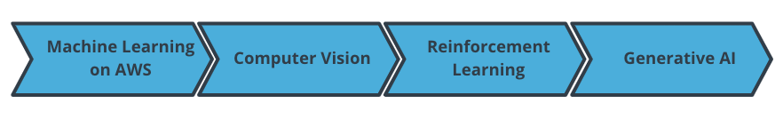

The lesson outline

By the end of the lesson, you will be able to:

* Identify AWS machine learning offerings and understand how different services are used for different applications.
* Explain the fundamentals of computer vision and provide examples of popular tasks.
* Describe how reinforcement learning works in the context of AWS DeepRacer.
* Explain the fundamentals of generative AI and its applications, and describe three famous generative AI models in the context of music and AWS DeepComposer.

We hope this will be an interesting and exciting learning experience for you.

Let's get started!